**EDTS Test Tech Doc**

* **Git Repo Link:**

[**https://github.com/necro31/testedts**](https://github.com/necro31/testedts)

* **DB Connection using Docker**
  1. **Terminal Command create new container :**

**docker run --name postgres-container-edts -e POSTGRES_USER=albert -e POSTGRES_PASSWORD=secret -e POSTGRES_DB=albert -d -p 5432:5432 postgres**

* **Swagger HTML test (after running)**

[**http://localhost:8080/swagger-ui-demotest.html**](http://localhost:8080/swagger-ui-demotest.html)

* **API Doc**

**1. Get All**

1. Endpoint : /v1/employees/get-all
2. Request : Post
3. Response :

[

{

"id": 0,

"createdAt": "string",

"updatedAt": "string",

"name": "string",

"salary": 0,

"grade": "MANAGER",

"salaryWithBonus": 0,

"deletedAt": "string"

}

]

**2. Create**

1. Endpoint : /v1/employees/Create
2. Request : Post
3. Request Body :

{

"name": "string",

"salary": 0,

"grade": "MANAGER"

}

1. Response :

{

"id": 0,

"createdAt": "string",

"updatedAt": "string",

"name": "string",

"salary": 0,

"grade": "MANAGER",

"salaryWithBonus": 0,

"deletedAt": "string"

}

**3. Update**

1. Endpoint : /v1/employees/update/{id}
2. Request : Put
3. Request Body :

{

"name": "string",

"salary": 0,

"grade": "MANAGER"

}

1. Response :

{

"id": 0,

"createdAt": "string",

"updatedAt": "string",

"name": "string",

"salary": 0,

"grade": "MANAGER",

"salaryWithBonus": 0,

"deletedAt": "string"

}

**4. Delete**

1. Endpoint : /v1/employees/delete/{id}
2. Request : Delete

**5. Delete Bulk (More than one id)**

1. Endpoint : /v1/employees/bulk-delete
2. Request : Delete
3. Request Body :

//List id

[

0,

1,

2,

3

]

* **Database**

**Entity**

1. ms_employee

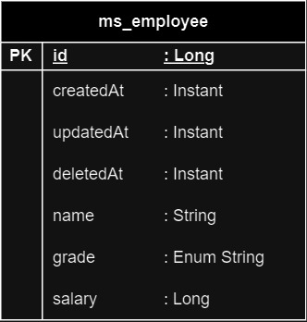

**id (Type: Long):**

This is a unique identifier for each employee. It is automatically generated by the database.

**createdAt (Type: Instant):**

This field holds the timestamp of when an employee record is created.

**updatedAt (Type: Instant):**

This field is updated with the timestamp whenever an employee record is modified.

**deletedAt (Type: Instant):**

If an employee is soft-deleted, this field will hold the timestamp of when the deletion occurred.

**name (Type: String):**

This field stores the name of the employee.

**salary (Type: Long):**

It represents the salary of the employee.

**grade (Type: Enumerated String)**

**(“MANAGER”/”SUPERVISOR”/”STAFF”)(uppercase):**

This field represents the job grade or level of the employee. It is stored as a string in the database. “MANAGER” ,”SUPERVISOR” or ”STAFF” only.